SPANISH PROJECT SUMMARY

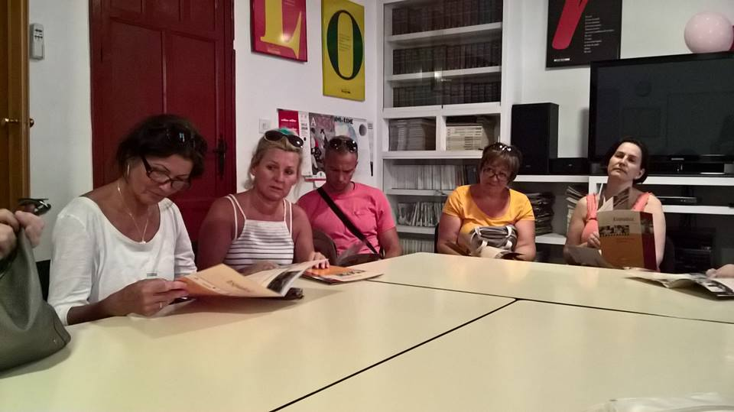
In the project titled TUTORIAL PROGRESS AND UPGRADING ALL 4 SKILLS IN MULTILINGUA 15 participants were involved. All of them were teachers of languages, tutors and experts, belong to Balázs Győző Református Gimnázium Magyar-Angol Két Tanítási Nyelvű Általános Iskola. The major objective of the project was to carry out a job-shadowing mobility when the 4 basic skills are studied. Participants’ need was to confirm their daily applied methods – used in the bilingual primary school - by revising and adjusting the latest themes in language learning via the 4 skills.
Job-shadowing introduced the up-to-date schemes while experts were observing the school and the class with the mentor’s attitude and style. During the workshops the targeted questions were asked then the well-qualified tutors were ready to answer them and they all discussed the matters on the spot. The job-shadowing displayed and represented the Spanish techniques, introduced a different educational system to the project participants. Teaching the 4 basic skills: writing, reading, listening and speaking could appear differently in different aspects. Teaching languages could own other approaches, as they are listed: 1. Teaching general English 2.) Teaching other subjects in English (Physics or Civilization in English) or 3.) Teaching English when preparing for the language exam. Each of them needed alteration in teachers’ methodology.
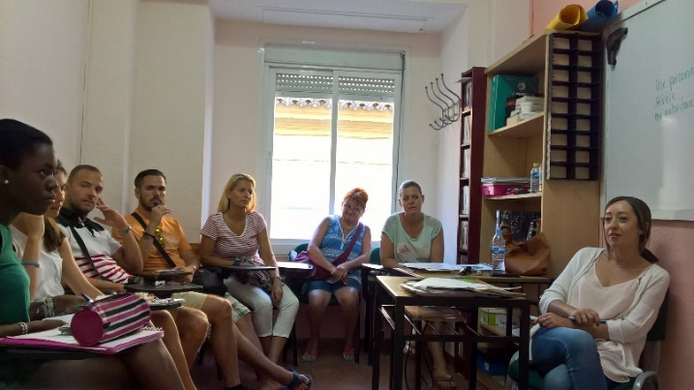
All-4 Skills aimed to evolve the boast of teaching materials and methods in teaching foreign languages in order to provide participants with as many alternatives as it could. It also gained development of practical and theoretical studies with the 4 skills to scope professional development, multilateral purposes in bilingual primary schools and transparency of foreign languages. The major activities of the project were organized by Europroyectos Erasmus Plus S.L - in Córdoba and Granada- and other schools involved in the project such as primary schools, language schools and educational institutions. All-4-Skills project identified the basic skills and it refreshed, updated the knowledge of teaching and it had a focus on confirming the major elements with a little modification. All-4-Skills interpreted the practical and theoretical acquaintances combining the 3-unit of knowledge, skills and competencies.
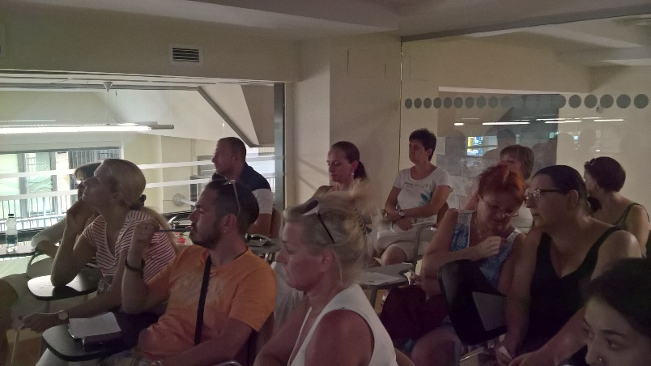
During the whole project we profiled, summarized and sophisticated the skills of reading, writing, speaking and listening as to learn the priorities of the project. We acknowledged the importance of teaching ‘what-how-why ‘in order to develop the basic skills. The 3 main phases of the job-shadowing mobility were I. Explore and Collect Period, II. In-Progress Period, III. Upgrading Period. Balázs Győző Református Gimnázium Magyar-Angol Két Tanítási Nyelvű Általános Iskola and Europroyectos Erasmus Plus S.L. worked on the project realization mutually. Both of them carried out the workshops, they shared experiences, completed technical visits and made a lot of discussion on the project topic. The following technical terms were going to be reflected: ESP or ESOL, - teachers’ upgrading, - tutoring and feed-back, - guided practice, - sub-skills, - creative and cognitive writing –holistic approaches - CLIL, Content Language Integrated Learning- 4-skills, - formal and non-formal learning, - foreign languages one-stop-shop, one-to-one attitude, - CEFR (Common European Framework of Reference). The teachers’ mobility produced an outcome as the participants has developed their personal skills and they are able to possess the following aptitudes: 1. Applying the latest methods confidently 2. Implementing the best practices 3. Identifying the key themes, methods and their use and function. 4. Disseminating the added value of the job shadowing 5. Linking to a quality educational background 6. Being able to change their behaviour and attitude in order to demolish barriers, implementing the transferred knowledge – all of them were resulted by the project. Besides all these facts, the comprehension of IT skills joined by the basic ones -in English language learning – which was still important and not a fact which could be neglected these days. Interactive platforms developed teaching matters in many cases. During the mobility participants publicized the project results on Facebook, Blogspot and other websites. Each participant made an individual project work which we disseminated on dissemination events. Finally, the project’s most important outcome and assessment were displayed in the participants’ personal and professional development by the guidance of life-long learning projects.

Visited Institutions: JUNTA DE ANDALUCÍA, MULTIDIOMAS (Kids Brain), COLEGIO INTERNACIONAL DE GRANADA, ESCULA INTERNACIONAL DE ESPAÑOL (Castila), ESCUELA MONTALBAN, EUROLINGUA, CLC IDIOMAS, KAIROS TOWN, MONTESSORI DREAM, GARABATOS (HELEN DORON)

