PROJECT SUMMARY

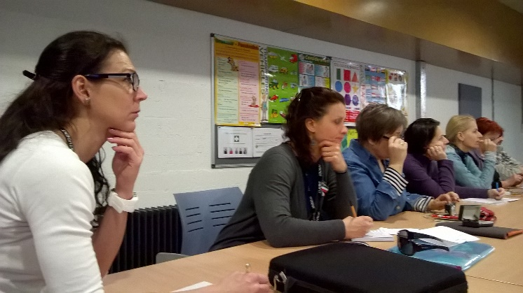
In the project titled “2 SAT” 8 participants of Balázs Győző Református Líceum were involved. They were mentors, tutors who intended to gain and utilize experience during the 14-day-study visit in Northern Ireland. The project focused on learning new modules of vocational training and education to modernize the applied technologies and balance the traditional and advanced ICT applications in secondary education.
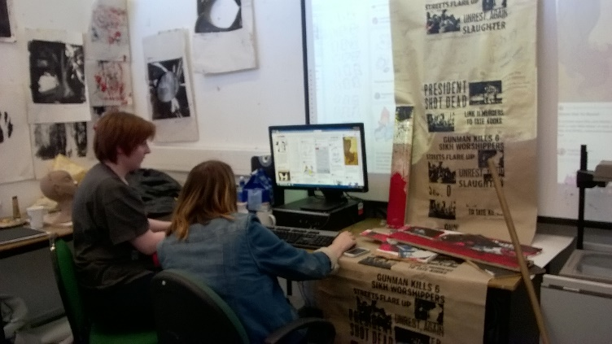
The Smart And Traditional education on Secondary Art Trades described, detailed the main priorities of the study period. The major goal was to upgrade the vocational training while using up-to-date methods and digital techniques. We aimed to harmonize different elements when combining the instructive (traditional) and constructive (modern) pedagogy via vocational education in theory and practice. Our major tasks: 1.) In general: VET is continuously changing and experts, mentors openly follows the modifications, alterations, refreshed themes, structures which are essentially needed in education of theory with practice. Refined schemes were needed to be introduced to broaden acquaintances in order to be appropriate and relevant in the integrated European vocational education and training. Since there were good practices of the EU established in Londonderry, we were ready to study the latest interactions engaging our experts’ personal development to be able to improve education. 2.) Specifications: BGYRL has Graphic Designer (54-211-04) Moving Image and Animation Designer (54-213-03) Theatre Dancer (54-212-09) classes. By the experts’ mobility, mentors of VET were able to complete changing of educational experiences, knowledge transfer in a mutual assistance.
In the project of BGYRL new approaches were implemented and multimedia essentials of education were harmonized with the art and media trades’ orientation. Mentors teaching vocational education proposed to develop trades’ skills and selected the most appropriate trade-orientated implication. They got easy access to authentic online, smart platforms, and applications leading to promotion. In a multicultural inspiring background the participants’ knowledge was widened, they experienced them by fulfilling the project tasks.
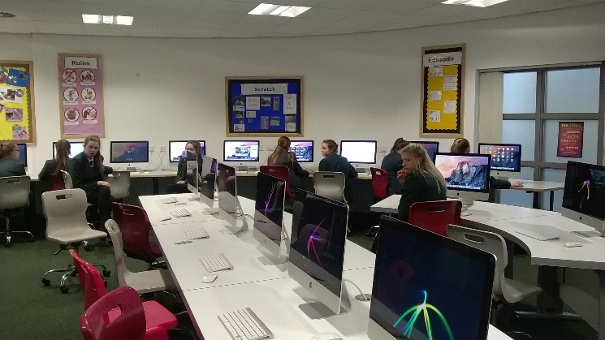
Using a foreign language in a country with different cultural features made the members of the project team be empowered and more self-confident. It also developed the individual’s skills of problem-solving. Our team met devoted students to merge VET skills with digital competencies and made transfusion according to the labour market. Londonderry took the advantages of owning the title of ‘the City of Culture’ of when it evolved the regeneration and reorganization processes in educational fields as well.
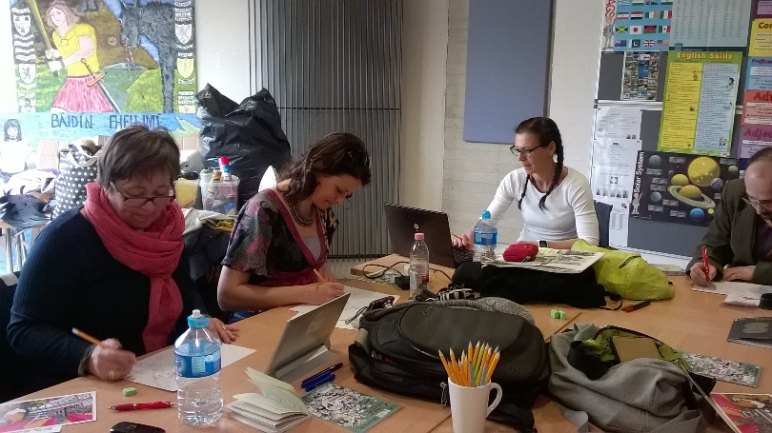
Each consequence of social inclusion in education and media was introduced by NWA. Tutors were provided by ideas about quality smart-schooling. Project priority outlines the trade-orientation + all smart tools + social inclusion which were in an educational entity and presented in workshops. “2 SAT” project realizes a 2-week-study mobility carrying out workshops, meetings. Realizations of technical visits: NWA, North West Regional College, St. Cecilia College, Community Art Centre, YENI, People’s Gallery of Murals, Belfast Titanic Interactive Museum, Giant’s Interactive Centre, Fab Lab, Playhouse, and The HUB. Steering Group Meetings, and talk shops wished to change and share views, opinions. “2 SAT” project supported effective and creative learning by using ICT, smart platforms in the dynamic and rapidly developing VET when preparing for final trades’ exams. Smart communicational tools generated interviews, videos, and blog outcomes, which were recorded in the transition of interactive knowledge material. Participants made reports on Facebook and blogspot sites.

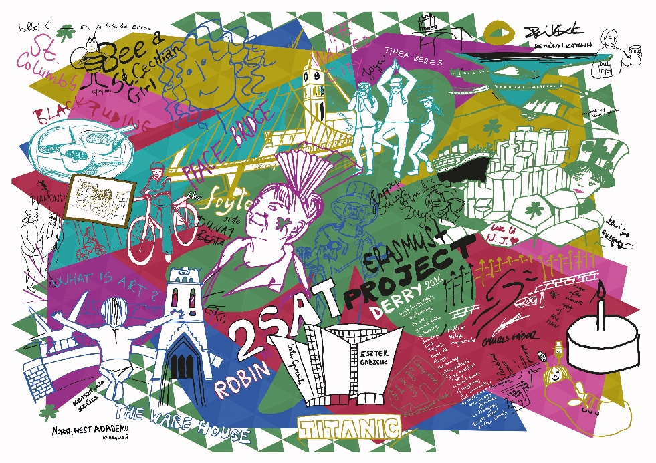
After sharing high-quality, unique and constructive experience with colleagues in follow-up dissemination acts the outcome and entire revenue of the project is spread with a long-run project contribution to the schools of Balázs Győző Líceum and regional VET institutions.

